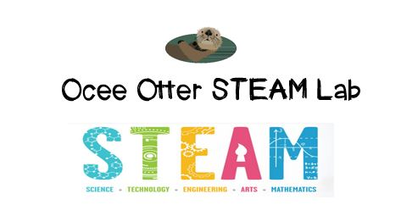
May, 2016
Dear Parents,
Want to continue STEAM fun at home this summer? We have assembled a packet of twelve challenges for you and your young problem-solver to try. The challenges cover a wide range of science disciplines. For each, there is background information, a goal, a list of suggested materials (everyday household items), and directions. The directions are really “suggestions”—feel free to experiment with many ways to meet the goal. For each challenge, please encourage your young problem-solver to practice the steps of the Design Process: plan, build, test, re-design, and reflect. These challenges were adapted from https://www.curiositymachine.org.
Have fun!
Ocee Elementary School

Challenge: Design a Bird Beak
Background Information
The design and effectiveness of a bird’s beak has a huge impact on their success as a species. Birds who are able to eat more food with less effort will be able to migrate more easily when harsh weather arrives. Some birds are able to eat hard foods, like nuts, which offer a high amount of calories (aka fuel). This is because their beaks use mechanical advantage to break through the nut’s shell easily. Mechanical advantage gives birds the ability to amplify the force of their beaks. Though beaks vary in size and shape, the overall structures of beaks are similar. Most bird beaks allow for a large load (or food in this case) to be consumed because the fulcrum, or area of the beak that permits movement, is very sensitive to effort, or the amount of energy, that it takes to move the beak. Because beaks have this special combination of fulcrums, parts sensitive to effort and the ability to accommodate a large load they are able to crack open hard nuts and seeds!

Goal
Engineer a beak that will allow you to pick up as much food as possible in one try without using your hands.

Suggested Materials
- sticks
- rubber bands
- paper clips
- plastic cutlery
- grains
Suggested Directions
- Connect your pencils together with rubber bands to create a system that closes when you apply effort with your hands. Feel free to use a variety of long, rigid objects.
- Think of the connection areas of your long, rigid objects as fulcrums—what materials and structure will allow for the easiest movement of the pencils?
- Connect your spoons or “food grabbers” at the end of your system. You’re ready to begin testing your design!

Challenge: Design a Suspension Bridge
Background Information
Engineers look to some of nature’s smallest creatures for inspiration. Spider webs are extremely good at withstanding tension, or being stretched. In addition to building a web with strong and flexible spider silk, the spider starts building with a Y-shaped structure that provides the core support for the web and helps to tolerate extreme tension (like suspension cables on a bridge). The spider then incorporates triangular shapes, criss-crosses, and spiral structures to strengthen the web (like trusses that structural engineers use in bridges and skyscrapers). Engineers use these same types of structures to strengthen bridges that support the weight of cars and people.

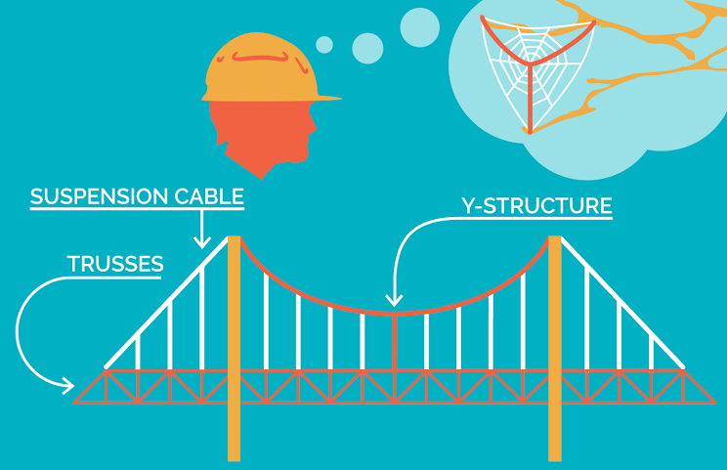

Goal
Build a bridge that can withstand weight (pennies) and add trusses and suspension to your design so that it can hold up more weight.

Suggested Materials
- Toothpicks
- Gumdrops
- Large cups
- Small cup
- String
- Paper clips
- Pennies
- Tape

Suggested Directions
- Set up your bridge site! Place two desks or chairs about 10 inches apart. Your bridge will span the space between.
- Poke the ends of the paper clip into opposite sides of a paper cup near the rim. Use a second paper clip to make a hook to hang the load tester from the bridge.
- Construct a bridge from toothpicks and gumdrops, and place it so that it spans the gap between the two desks or chairs. Use the load tester to see how much weight it can hold.
- Add some trusses to your bridge, and see how much more weight it can hold.
- Now turn your truss bridge into a suspension bridge to make it even stronger! Build towers for the bridge to suspend from, as well as cables to connect the floor of the bridge to the towers. See how much more weight your suspension bridge can hold.

Challenge: Create an Edible Dip
Background Information
Dip ingredients are as varied as the places they come from! Hummus and baba ganoush, made from mashed beans and eggplant, originated in Western Asia. Guacamole and many tomato and onion based salsas are popular in Mexico and other countries with hot climates. In the U.S., creamy dips made from cheese, sour cream, or yogurt are popular. Dip possibilities are endless!
One thing every great dip recipe has is a balanced flavor. The main flavor types are:
- Sweet flavors, caused by ingredients that contain sucrose such as honey and fruits.
- Sour flavors are caused by acidic ingredients, such as limes.
- Bitter ingredients such as cocoa and citrus peel can be used to compliment other flavors.
- Table salt (NaCl) is used in almost all recipes to compliment other ingredients.
- Umami flavors are savory, and can be found in meats, tomatoes, mushrooms, vinegar, and cheese.
Goal
Make your own recipe for a dip using an unusual ingredient. See what tasty combinations you can create!

Suggested Materials
- large bowl
- classic dip ingredients (some from different flavor categories)
- 1 unusual food (any ingredient that isn’t usually used in a dip, but has a unique flavor)
Suggested Directions
- Gather classic dip ingredients from different flavor categories (sweet, sour, bitter, salty, and umami), as well as an unusual ingredient that can replace a classic ingredient in your recipe.
- Write out 3 recipes, all using the unusual ingredient you chose. The recipes should be identical, except for the amounts of the special ingredient used. Your goal is to find the perfect balance of flavors.
- Mix up your 3 recipes, and conduct taste tests!

Challenge: Design a Jumping Machine
Background Information
Kinetic energy is the energy used to make something move. Potential energy is “stored” energy.

Goal
Build a machine that can store potential energy in rubber bands. Your machine should “jump” when you release it.

Suggested Materials
- sticks
- rubber bands
- paper clips
- drinking straws
Suggested Directions
- Find different ways to attach your rigid objects and rubber bands together. Winding or stretching a rubber band can be a great way to store elastic energy!
- See if you can create a latch system for your design, so that it releases its elastic energy when the latch is released (similarly to how an umbrella latch is used to release open an umbrella, and how the mantis shrimp kept its are cocked and ready to punch!).
- Test your design, and see how far it can jump!
- Once you have a jumping machine, find a way to make the machine jump using only 1 finger. Here are a few ideas:
  - Think of how latches on umbrellas work to hold them open. How does the latch keep potential energy from being released until the latch is pushed?
  - Think of how the button on a tape measure can keep it from winding up and also allow the tape to snap back into its holder.

Challenge: Design a Submarine
Background Information
Submarines are special ships that can go completely under the water’s surface and then come back up again—a trick that other ships usually can’t do! A real submarine has different compartments that control how it will sink or rise to different heights of the ocean. It has metal tanks called ballast tanks that hold different amounts of air and water depending on if you want to submarine to rise higher or sink lower. The submarine can pump water and air into and out of the ballast tanks to make it heavier or lighter and help it move up and down in the water! Imagine what will happen to your submarine if all the ballast tanks are filled with air only. I bet you can guess! It will rise towards the surface of the water. Why? Because water is more dense and heavier than air, a submarine filled with air will float above the heavier water surrounding it. By introducing more air, you are making your submarine more buoyant which causes it to float opposite to have gravity causes objects to sink.

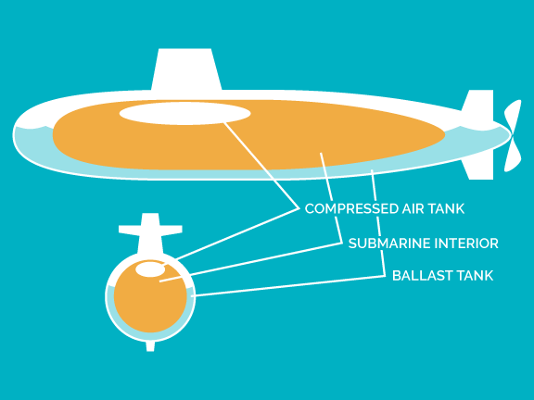

Goal
Build a submarine that can sink and rise by designing ballast tanks using balloons and adding weights to change the buoyancy.

Suggested Materials
- plastic tubing
- plastic syringes
- recycled plastic bottle
- balloons
- pennies
- tub
- water

Suggested Directions
- Attach the balloon to each end of the tubing using rubber bands. Now, cut your tubing in half so that you now have two short pieces of tubing, each attached to a balloon.
- Fill your syringes with air, and then attach them to the newly cut ends of the tubes.
- Make two holes on the empty bottle and feed the balloon ends through the holes. Want to make sure that the balloon won’t fall out.
- Add weights to the bottle and place the bottle under water. Make sure the syringe does not fall into the water and try to remove as much air as possible from the bottle.
- Once you have sunk the submarine to the bottom of the tub, use the syringe to blow up the balloon to get the submarine to rise.

Challenge: Build a Large Tetrahedra
Background Information
A tetrahedron is a pyramid with a triangular base. Tetrahedral have four faces, four points and six edges.

Goal
Build a 3-dimensional structure consisting of only 2-dimensional triangles.
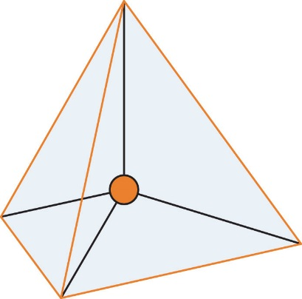
Suggested Materials
- Pipe cleaners
- Coffee stirrers
- Scissors
Suggested Directions
- Cut segments of pipe cleaners.
- Connect three coffee stirrers together with the pipe cleaners to make a triangle. All the sides of the triangle should be the exact same length.
- Make another triangle
- Now, take the two triangles and join them together to make a tetrahedron. This may take some practice to figure out.
- Count the triangle faces, do you have four? It should look like a triangular pyramid that is a triangle on all sides.
- Repeat the steps above and continue to make tetrahedral using the pipe cleaners to join the stirrers together.
- Once you have built at least four tetrahedral, try different ways to attach them together. They can be attached at the points, at the edges, or at the faces. Stack them together to make even larger tetrahedral.
Challenge: Measure Waves
Background Information
Waves are oscillations, or back and forth movements, that travel through matter such as air, water, or even solids such as metal or earth. There are three main characteristics of waves, known as frequency, amplitude, and wavelength.
- Frequency: the number of waves that pass a specific point in a second
- Amplitude: the height of a wave from crest (highest point) to trough (lowest point)
- Wavelength: the distance between crests of a wave
Goal
Build a machine through which waves can travel. Record wave characteristics using a signal recording device.
Suggested Materials
- Tape
- Sticks
- Clothes pins
- Marker
- Recycled paper
Suggested Directions
- Lay your tape on a table with the sticky side up and carefully place popsicle sticks across the tape.
- Think about how you want to space the sticks on the tape, and how it might affect your wave. Also think about how many sticks you want to place in the machine, and how long it should be.
- Once all the sticks are in place, lay another strip of tape on top of the first one, so the sticks are secured on top and bottom.
- Attach the ends of the tape to two solid holding spots, like table edges or chair backs, so that the tape is a taut.
- Add weights to the end of the sticks using pennies or clothespins. Adjust the weights so that each stick is balanced and lays flat.
- Make a signal recording device by attaching a marker to the last one or two popsicle sticks.
- Place a piece of paper (or a spinning paper-covered cylinder) so that the marker just brushes against the paper’s surface.
- Tap one end of the machine to send a wave and slowly slide the paper in one direction to see what the marker records on the paper!
Challenge: Octopus Camouflage
Background Information
Cephalopods, such as squid, cuttlefish, and octopus, are able to change their skin color, pattern, and texture to camouflage in any environment. One secret to this masterful mimicry is due to expandable chromatophores, or pigment sacs, in the animal’s skin. Each chromatophore is filled with a different colored pigment. When muscles attached to the chromatophore pull, it expands to force the pigment into a disk shape. As the muscles relax, the pigment sac is allowed to contract, shrinking into an almost undetectable dot on the skin surface.

Goal
Build your own octopus chromatophores that can expand and contract to mimic what happens in real octopus skin.

Suggested Materials
- recycled cardboard
- string
- scissors
- balloons
Suggested Directions
- Cut out a flat piece of cardboard into roughly the shape of a square, measuring 1 foot on each side.
- Use scissors to cut a balloon into a flat rubber sheet, this will be your pigment sac.
- Cut small holes near the edges of the stretched out balloon and tie a piece of string or rubber band through them. You can cut as many holes in as many places you feel is necessary.
- Using the scissors or a hole punch poke holes in the cardboard sheet. Thread the untied end of the string or rubber bands into the holes in the cardboard. Tie all the loose ends together on the back side of the cardboard.
- Test your design! Pull on the strings or rubber bands to see the balloon stretch, just like the pigment sacs in the octopus’s skin!

Challenge: Build a Mechanical Linkage
Background Information
A mechanical linkage is a system of rigid levels or rods (often called “links”) connected together that move in a coordinated manner. By exploring different linkage systems, you can gain a vocabulary of mechanical systems such as cams, cranks, and joints.

Goal
Build a mechanical linkage on a handmade pegboard.

Suggested Materials
- recycled cardboard
- hole puncher
- popsicle sticks
- brass fasteners
Suggested Directions
- Poke many holes into a piece of cardboard. They can be in neat rows, or more randomly spaced. This is your “pegboard.”
- Poke holes into strips of cardboard or popsicle sticks. These will act as your links.
- Use brass fasteners to attach the strips to each other and to the pegboard you made. Experiment with different arrangements and see what different kinds of motions you can make with your board. Some won’t work, some will. Be creative!

Challenge: Build a Joint
Background Information
What type of joints, or places where two bones meet, do humans have? Observe how your elbows move – do they move in only one direction, two or more? In your body, muscles work together to pull and move your bones, which act like levers. You are going to use fishing line to mimic the way muscles pull on bones and joints to create body movement, ands straws to mimic the bones. By observing our own bodies and living things in nature we can create machines that mimic our observations!
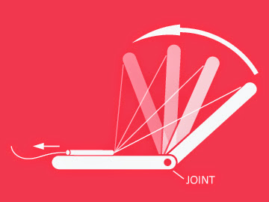

Goal
Build a joint mechanism that mimics human body joints.

Suggested Materials
- drinking straws
- string
- scissors
- tape
- push-pin
- beads
Suggested Directions
- Take a pushpin and puncture a hole near the top of the bendy part of the straw.
- Tape a bead to the long part of the straw.
- Thread string through the puncture hole near the top of the straw and tie a knot. You may want to put a piece of tape over the knot to make sure it does not slip.
- Run the rest of the fishing line through the bead.
- Pull the excess string and you should be able to control the top of the straw. You have just created a joint mechanism!
Challenge: Build a Ball and Socket Joint
Background Information
One part of the human body that determines much of the way that our bodies move is the joint. Joints are the points of our bodies where two bones meet, such as your knee, where your tibia and femur (your thigh and shin bones) meet, and your shoulder. Your knee is one of many hinge joints in your body that allow backward and forward movement. However, your shoulder is one of just four ball and socket joints in your body – two each of shoulders and hips! These joints allow movement in many directions, allowing the widest range in motion of any joints in your body.

Goal
Design your own ball and socket joint.

Suggested Materials
- recycled cardboard
- rubber bands
- tennis ball
- tape
- scissors
- rulers
Suggested Directions
- Cut two rectangles of cardboard, each about a foot long and 1-2 inches wide.
- Fold each strip into a “U”. Cross these strips over each other so that together they form a squared cup shape.
- Place a tennis ball inside the cardboard cup, so that about ⅓ of the ball is above the rim of the cup.
- Use rubber bands to hold the cup rim together. The ball should be able to swivel freely within the cardboard.
- Use rubber bands or tape to attach a ruler to the tennis ball.
- Use rubber bands or tape to attach another ruler to the underside of the cardboard cup.

Challenge: Build a Seed Jumper
Background Information
Maple seeds have a helicopter shape which helps them to slow down as they fall. This gives the wind time to catch the seed. Dandelion seeds are very light and have a parachute made of little hairs that allow the wind to carry them far. Other seed types have large fins to help them cut across the air more easily than falling downward.

Goal
Design a seedpod that can travel far and wide.

Suggested Materials
- drinking straws
- playdough
- tape
- recycled paper
Suggested Directions
- Create a seedpod to carry your seed with straws and tape.
- Create little wings or blades on the seedpod by cutting off part of the straw and attaching tape or paper.
- Attached a small amount of playdough to the bottom of your pod. This will be your “seed”.
- Find a high place with no wind to drop your seed pod and watch what happens!
