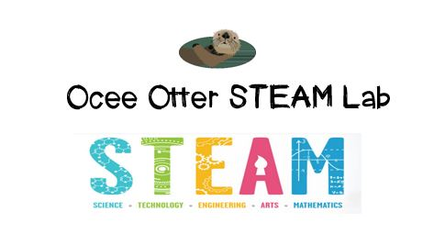
Dear Kindergarten Parent,
We had so much fun during our first visit to the STEAM Lab. We did a really challenging project to practice our problem-solving skills called “Save Fred the Worm.” We had to move objects using limited tools to accomplish a goal. We learned that balance is important! And we learned that it’s ok to try one plan and then modify it and try again.
This lesson incorporated many standards.
Science P2. Students will investigate different types of motion.
Science P3. Students will observe and communicate effects of gravity on objects.
Science CS3. Students will use tools and instruments for observing, measuring, and manipulating objects in scientific activities.
Art MC.1 Engages in the creative process to generate and visualize ideas.
Talented and Gifted Higher Order Thinking 5. The student predicts probable consequences of decisions.
Talented and Gifted Creative Problem-Solving 4. The student demonstrates skills in fluency and flexibility to solve problems or create new products.
Talented and Gifted Creative Problem-Solving 9. The student recognizes and assumes risks as a necessary part of problem solving.
Check out the Resources page of the STEAM Lab website for ideas on where to find more fun projects like this one. http://oceesteamlab.weebly.com/
Please ask me to tell you why balance is important in our lives. Also, please help me brainstorm times in my life when I might need to try a plan to solve a problem and then try a different plan if the first one didn’t work. To learn more about worms, we could read Diary of a Worm by Doreen Cronin and discuss the best and worst things about being a worm.
With scientific creativity, Your young problem-solver

