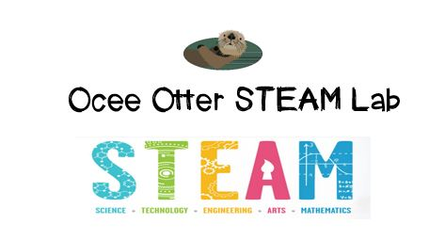
Dear Kindergarten Parent,
We had so much fun today during our visit to the STEAM Lab using Lego bricks and the Lego Education LearnToLearn Curriculum. We were trying to answer this question: How do designers make bridges both stable and beautiful? First we looked at photographs of various types of bridges. Then we built a bridge using our Legos, tested it for stability, and compared our designs to others in the class. Then we challenged ourselves by making our bridges taller, longer, and more stable. Check out pictures of us working on http://oceesteamlab.weebly.com/.
This lesson incorporated many standards.
SKP3. Students will observe and communicate effects of gravity on objects.
MGSEK.MD.1 Describe several measurable attributes of an object, such as length or weight.
MGSEK.MD.2 Directly compare two objects with a measurable attribute in common, to see which object has “more of”/“less of” the attribute, and describe the difference.
MGSEK.G. 5 Model shapes in the world by building shapes from components.
Art MC.1 Engages in the creative process to generate and visualize ideas.
Art CU.2 Views and discusses selected artworks, cultures, and artists.
Art PR.3 Understands and applies media, techniques, and processes of three-dimensional works of art using tools and materials in a safe and appropriate manner to develop skills.
Talented and Gifted Creative Problem Solving 4 The student demonstrates skills in fluency and flexibility to solve problems or create new products.

Did you know that many of the streets around us are named after former bridges? Learn more at https://en.wikipedia.org/wiki/Historic_bridges_of_the_Atlanta_area
The pedestrian Flower Bridge and Canopy Walk at the Atlanta Botanical Gardens give an excellent comparison of historic versus modern bridge design and would make a great family field trip. Drive through Spaghetti Junction (intersection of 85 and 285) to experience bridges of different heights. Check out the Resources page of the STEAM Lab website for ideas on where to find more fun projects like this one. http://oceesteamlab.weebly.com/
With scientific creativity,
Your young problem-solver

