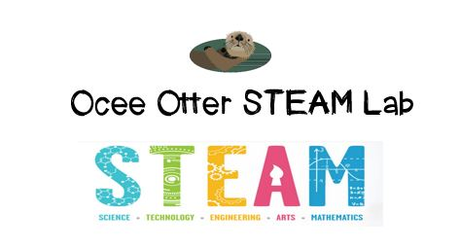
Dear Kindergarten Parent,
We had so much fun during our visit to the STEAM Lab! We analyzed 9 different types of real bird feathers with magnifying glasses to compare and contrast them to try to answer this question: Why do different birds have different feathers? We related this to art by comparing the representation of birds in Chinese art with that of the artist John James Audubon. I even came home with a real peacock feather to share with you!
This lesson incorporated many standards.
Science L2 Students will compare the similarities and differences in groups of organisms.
Science CS5 Describe and compare things in terms of number, shape, texture, size, weight, color, and motion.
Talented and Gifted Higher Order Thinking 3 The student conducts comparisons using criteria.
Talented and Gifted Advanced Research Skills 4 The student selects appropriate research tools and methodologies to conduct scientific investigations.
Talented and Gifted Advanced Research Skills 5 The student gathers, organizes, analyzes, and synthesizes data from multiple sources to support or disprove a hypothesis.
Art CU2 Views and discusses selected artworks, cultures and artists

The “Birds of Prey” show at Callaway Gardens would be a great family field trip to extend this lesson.
Did you know that early attempts by people to fly were based upon watching how birds fly? But planes have changed a lot over the years! There are many aviation museums close by where we could learn more about flight, including the Delta Flight Museum, the Museum of Aviation, the National Museum of Commercial Aviation, and the Marietta Aviation Museum. We could even watch planes take off and land while eating at the 57th Fighter Group Restaurant at the Peachtree DeKalb Airport!
With scientific creativity,
Your young problem-solver
PS Check out the Lessons page to see pictures of this activity, and the Resources page for ideas on where to find more fun projects like this one. http://oceesteamlab.weebly.com/

