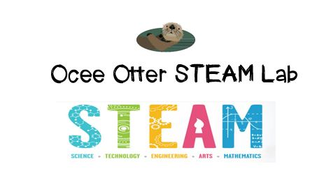
Dear Kindergarten Grade Parent,
We had so much fun during our visit to the STEAM Lab! We placed objects in a bag tied to a helium balloon to try to make it float half way between the floor and the ceiling. We predicted what might work, modified our plan based upon the results, and recorded our trials. We used this experiment to discuss the question: Why is balance important? Did you know that a company called Arigami creates sculptures with balloons? The artists call it “the fine art of folding air,” and we saw examples of famous artworks and animals made entirely from balloons!
This lesson incorporated many standards.
Science P3 Students will observe and communicate effects of gravity on objects.
Talented and Gifted Higher Order Thinking 5 The student predicts probable consequences of decisions.
Talented and Gifted Creative Problem Solving 3 The student incorporates brainstorming and other idea-generating techniques to solve problems or create new products.
Talented and Gifted Creative Problem Solving 4 The student demonstrates skills in fluency and flexibility to solve problems or create new products.
Art CU2 Views and discusses selected artworks, cultures and artists.

Did you know that there are even balloons big enough for people to ride under? Please help me learn how this is possible!

With scientific creativity,
Your young problem-solver

PS Check out the STEAM Lab website to see pictures of us working. And the Resources has ideas on where to find more fun projects like this one. http://oceesteamlab.weebly.com/

