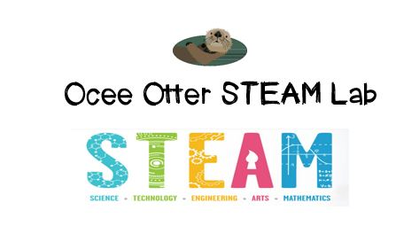
Dear Fifth Grade Parent,
We had so much fun during our visit to the STEAM Lab! We worked with a buddy on Qbitz puzzle challenges. We re-created a picture pattern using clues such as symmetry and fractions. We learned that flexible thinking is very important, because when our first idea didn’t work we had to try another. We also learned that developing our spatial reasoning and memory skills will help us! And, did you know that an artist named Doug Powell creates mosaic pictures using only old puzzle pieces?
This activity addressed many standards:
Science P1 Students will verify that an object is the sum of its parts.
Talented and Gifted Creative Problem-Solving 4 The student demonstrates skills in fluency and flexibility to solve problems or create new products.
Talented and Gifted Higher Order Thinking Skills 6. Extrapolate visual-spatial patterns to determine relationships.
Visual Arts AR3 Explains how selected elements and principles of design are used in an artwork to convey meaning and how they affect personal responses to and evaluation of the artwork.

Please help me research what careers require spatial intelligence, such as mechanical engineering, urban planning, graphic arts, and geography.

With scientific creativity,
Your young problem-solver

PS Please check out the Resources page of the STEAM Lab website for ideas on where to find more fun projects like this one. http://oceesteamlab.weebly.com/

