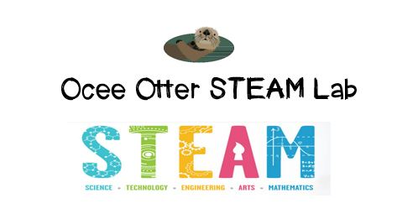
Dear Fifth Grade Parent,
We had so much fun in the STEAM Lab! Our Problem-Based Learning question was: Do our brains always recognize “truth” around us? First, we identified the parts of the brain and how neurons carry signals from all around our bodies to the brain. Then we completed several science experiments, including analyzing optical illusions, measuring reaction time, trying to do two things at once, and trying not to do something that we normally do involuntarily. We summarized our conclusions by creating analogies about the brain.
This activity addressed many standards:
Science L2. Students will recognize that offspring can resemble parents in inherited traits and learned behaviors.
Science CS3. Students will use tools and instruments for observing, measuring, and manipulating objects in scientific activities.
Talented and Gifted Program Advanced Research Skills 1. The student uses a variety of print and non-print resources to investigate a topic of interest.
Talented and Gifted Program Advanced Research Skills 4. The student selects appropriate research tools and methodologies (e.g., historical, descriptive, developmental, case, field, correlational, action, survey, interview) to conduct scientific investigations.
Talented and Gifted Program Creative Thinking Skills 7. The student uses analogies, metaphors, and/or models to explain complex concepts.

Some experiments we could do at home to creatively explore this question further include:
- Listen to different pieces of music and draw how they make us feel. Compare the drawings with each other and with other people.
- Dye foods a different color and see if they taste the same.
- Taste different foods with our eyes closed and nose closed. Can we identify each food?
- Put our fingers in cold water for 20 seconds and try to write. Can we write as well as with warm hands? Why or why not?
With scientific creativity,
Your young problem-solver

PS Check out the Resources page of the STEAM Lab website for ideas on where to find more activities like this one. http://oceesteamlab.weebly.com/

