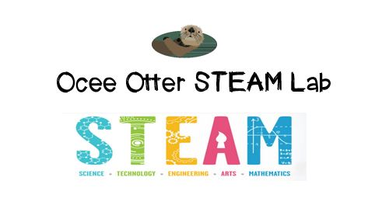
Dear Fifth Grade Parent,
We had so much fun during our visit to the STEAM Lab! We worked with a team to create multi-line programs on an iPad to make a Sphero ball display colors sequentially, each for a certain length of time. Our goals were to have Sphero light up only in primary colors, then in colors made from blending two primary colors, then in colors made from blending three primary colors. Did you know that color mixing with light is different than color mixing with paint? You use different combinations! And the amount of each color of light that you use will affect the shade of the final color! Then we programmed the Sphero ball to light up in a color pattern of our own design. I bet I could even use the Sphero to communicate in Morse Code!
This activity addressed many standards:
Mathematical Practice 8. Look for and express regularity in repeated reasoning: make generalizations about patterns.
Mathematical Practice 6. Attend to precision: use clear and precise language in discussions with others and in reasoning.
Science CS3. Use tools and instruments for observing, measuring and manipulating objects in scientific activities.
Art PR.2f Discuss properties of color (hue, intensity, value) and mix and use color schemes (analogous, monochromatic, complementary, neutral, intermediate).
Talented and Gifted Advanced Communication Skills 4. Use a variety of multi-media and innovative technology to create illustrations, models, charts, tables, and graphs as tools for communication.
Talented and Gifted Creative Problem Solving 9. Recognize and assume risks as a necessary part of problem solving.
Talented and Gifted Higher Order Thinking Skills 6. Extrapolate visual-spatial patterns to determine relationships.

We can learn more about mixing light to make colors by doing this simple and inexpensive experiment at home.
http://www.sciencebuddies.org/science-fair-projects/project_ideas/HumBeh_p021.shtml#summary
In this experiment, we were acting as physicists. Please help me research other topics that are part of the physics branch of science, as well as careers that scientists who love physics might have.

With scientific creativity,
Your young problem-solver

PS Check out the Lessons page of the STEAM Lab website for pictures of us working. And check out the Resources page for ideas on where to find more fun projects like this one. http://oceesteamlab.weebly.com/

