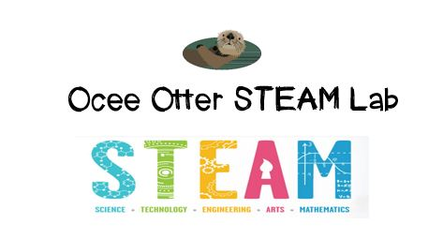
Dear Fifth Grade Parent,
We had so much fun during our visit to the STEAM Lab! We connected our science standard to the real world community by asking the question: How are chemical changes used in the practice of medicine? We learned that human blood is typed into four groups-A, B, AB, O-and that it’s important to know your blood type because getting the wrong blood during a transfusion could make you very sick. In our experiment, all the blood and liquids were simulated (no real human or animal blood was used). We added “antibodies” to “blood” samples to look for a chemical reaction which would tell us the blood group of the samples.
This lesson enriched our Life Science standards, in which we are learning about animal classification, cell structure, and inherited traits. It also addressed these Talented and Gifted Program standards:
Higher Order Thinking 3 The student conducts comparisons using criteria.
Higher Order Thinking 11 The student draws conclusions based upon relevant information while discarding irrelevant information.
Advanced Research Skills 4 The student selects appropriate research tools and methodologies to conduct scientific investigations.
Advanced Research Skills 6 The student develops and uses systematic procedures for recording and organizing information.

Please help me remember what my own blood type is and let’s brainstorm other connections between medicine and chemistry, like pharmacology. There are so many careers in medicine in addition to being a doctor or nurse, and there are so many careers that use chemistry. Please help me research these.
The free CDC Museum on Clifton Road would be a great family field trip to extend this lesson.
With scientific creativity,
Your young problem-solver
PS Check out STEAM Lab website for pictures of us working, and for ideas on where to find more fun projects like this one. http://oceesteamlab.weebly.com/

