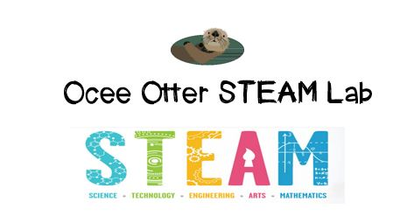
Dear Fifth Grade Parent,
We had so much fun today during our first visit to the STEAM Lab. We used Keva Brain Builder Planks to build 3D structures from 2D plans. We were trying to answer the question: Which perspective is best to determine proportion and composition of an object? We learned that balance is important! And we learned that it’s ok to try one plan and then modify it and try again. We related this to architecture by looking at some very unusual buildings!
This lesson incorporated many standards.
Science P1 Students will verify that an object is the sum of its parts.
Talented and Gifted Higher Order Thinking 8 The student separates one’s own point of view from that of others.
Talented and Gifted Higher Order Thinking 11 The student draws conclusions based upon relevant information while discarding irrelevant information.
Talented and Gifted Creative Problem-Solving 8 The student tolerates ambiguity when solving problems.
Talented and Gifted Creative Problem-Solving 9 The student recognizes and assumes risks as a necessary part of problem solving.
Art PR3 Understands and applies media, techniques, and processes of three-dimensional works of art using tools and materials in a safe and appropriate manner to develop skills.
Check out the Resources page of the STEAM Lab website for ideas on where to find more fun projects like this one. http://oceesteamlab.weebly.com/
Please help me brainstorm other objects that may look differently depending upon the perspective from which you view them.
Please help me brainstorm times in my life that my thoughts or feelings may change depending on my perspective (how I view an event or person).
With scientific creativity, Your young problem-solver

