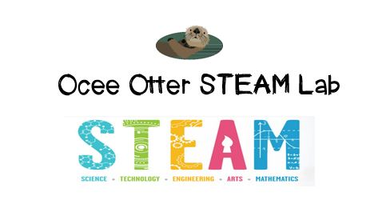
Dear Fourth Grade Parent,
We had so much fun in STEAM Lab this week playing LaserMaze! Did you know that a “laser” is very narrow and intense light that is only one wavelength? In this challenge, we arranged mirrors to reflect, block, and split a beam of light in order to hit a target. We needed to use some serious logic to strategize the path of the tricky laser beam! This game helped us build patience and confidence as we experimented with different placements and then improved our plans each time. We tried both beginning and expert level challenges. We also saw how one artist is “drawing” with light.
This activity addressed many standards:
Science CS 3. Students will use tools and instruments for observing, measuring, and manipulating objects in scientific activities utilizing safe laboratory procedures
Science Physical 1. Students will investigate the nature of light using tools such as mirrors, lenses and prisms.
Talented and Gifted Program Creative Problem Solving 2. The student designs, applies, evaluates, and adapts a variety of innovative strategies when problem solving.
Talented and Gifted Program Creative Problem Solving 4. The student demonstrates skills in fluency and flexibility to solve problems or create new products.
Talented and Gifted Program Creative Problem Solving 9. The student recognizes and assumes risks as a necessary part of problem solving.
Talented and Gifted Program Higher Order Thinking Skills 5. The student predicts probable consequences of decisions.
Some things we could do together to explore lasers include:
- Go to the Stone Mountain Laser Show.
- Identify how lasers are used in medicine.
- Read about Theodore Harold Maiman, the person who built the first laser in 1960.
With scientific creativity,
Your young problem-solver

PS Check out the Resources page of the STEAM Lab website for ideas on where to find more fun activities like this one. http://oceesteamlab.weebly.com/

