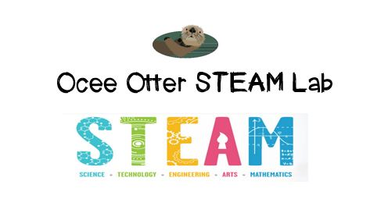
Dear Fourth Grade Parent,
We had so much fun during our visit to the STEAM Lab! We worked with a team to create multi-line programs on an iPad to make a Sphero robotic ball draw polygons. Our goals were to have Sphero draw a square and a triangle. In order to do this, we had to remember that a circle has 360 degrees, so the angles of a polygon with equal sides are a recognizable fraction of that total. We were trying to answer this question: How does the angle size of a polygon change as the number of sides increases?
This activity addressed many standards:
Math OA.5 Generate a number or shape pattern that follows a given rule.
Math NBT.6 Find whole-number quotients.
Math MD.5 Understand concepts of angle measurement.
Math G.2 Classify two-dimensional figures.
Mathematical Practice 8. Look for and express regularity in repeated reasoning: make generalizations about patterns.
Mathematical Practice 6. Attend to precision: use clear and precise language in discussions with others and in reasoning.
Science CS2. Students will have the computation and estimation skills necessary for analyzing data and following scientific explanations.
Science CS3. Use tools and instruments for observing, measuring and manipulating objects in scientific activities.
Talented and Gifted Advanced Communication Skills 4. Use a variety of multi-media and innovative technology to create illustrations, models, charts, tables, and graphs as tools for communication.
Talented and Gifted Creative Problem Solving 9. Recognize and assume risks as a necessary part of problem solving.
Talented and Gifted Higher Order Thinking Skills 6. Extrapolate visual-spatial patterns to determine relationships.

Please help me research what careers use geometry. Good places to start are http://work.chron.com/careers-require-geometry-10361.html and http://passyworldofmathematics.com/jobs-with-geometry/.
There are many fun geometry games and brainteasers on-line, including http://www.mathplayground.com/geometry_games.html and http://calculus-geometry.hubpages.com/hub/Geometry-Brain-Teasers-Shape-Counting-Puzzles.

With scientific creativity,
Your young problem-solver

PS Please check out the Lessons page of the STEAM Lab website for pictures of us working. Also, check out the Resources page for ideas on where to find more fun projects like this one. http://oceesteamlab.weebly.com/

