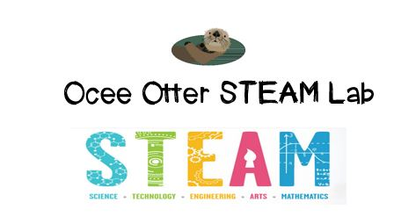
Dear Third Grade Parent,
We had so much fun during our visit to the STEAM Lab! Did you know that you can estimate the climate of a particular year in the past by carefully studying a tree's annual rings? Our investigation of tree samples helped us discuss this question: How do living things adapt to changes in their environment? The tree grew differently in wet years than it did in dry years. We related this to art by discussing the use of perspective in paintings of trees from Durand, Van Gogh and Wolodkowicz.
This lesson incorporated many standards.
Science L1 Students will investigate the habitats of different organisms and the dependence of organisms on their habitat.
Science L2 Students will recognize the effects of pollution and humans on the environment.
Talented and Gifted Higher Order Thinking 3 The student conducts comparisons using criteria.
Talented and Gifted Higher Order Thinking 11 The student draws conclusions based upon relevant information while discarding irrelevant information.
Talented and Gifted Advanced Research Skills 4 The student selects appropriate research tools and methodologies to conduct scientific investigations.
Talented and Gifted Advanced Research Skills 6 The student develops and uses systematic procedures for recording and organizing information.
Art CU2 Views and discusses selected artworks, cultures and artists

The Canopy Walk at the Atlanta Botanical Gardens would be a great family field trip to extend this lesson. It would let us view the trees from the top instead of the bottom, and then we could draw the trees from that unusual perspective. Also, please help me research how other plants and animals respond to changes in climate.
With scientific creativity,
Your young problem-solver

PS Pictures of us working are posted on the STEAM website. And, check out the Resources page for ideas on where to find more fun projects like this one. http://oceesteamlab.weebly.com/

