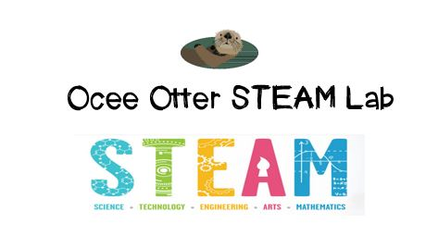
Dear Third Grade Parent,
We had so much fun making recycled hand-made seed paper! Before we started, the teacher read us the book X.E. Ecology from The Quirkles series, in which X.E. helps her friends make wise choices about what to do with trash. Our discussion question was: How can people use resources wisely in order to protect the environment?
This lesson addressed the following standards.
Science L2. Students will recognize the effects of pollution and humans on the environment.
b. Identify ways to protect the environment.
• Conservation of resources
• Recycling of materials
Art C1a Makes interdisciplinary connections, applying art skills, knowledge, and ideas to improve understanding in other disciplines.
The book Projects for a Healthy Planet by Shar Levine has many more fun simple environmental experiments.
Please help me brainstorm other art projects I could do with recycled materials. Could I make a collage from junk mail, for example? And did you know that Eric Carle’s book illustrations are really tissue paper collages? Let’s study one of his books and then try it ourselves! http://www.eric-carle.com/slideshow_collage.html
The Robert C Williams Museum of Papermaking at Georgia Tech would be a great family field trip to extend this lesson. http://www.ipst.gatech.edu/amp/

With scientific creativity,
Your young problem-solver

PS Check out the Resources page of the STEAM Lab website for ideas on where to find more fun projects like this one. And the Lessons page has pictures of this activity. http://oceesteamlab.weebly.com/

