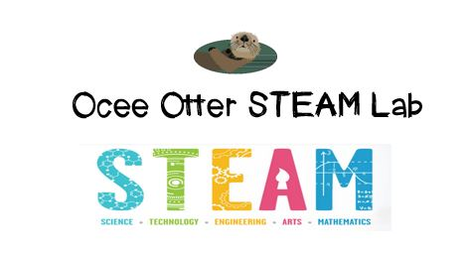
Dear Third Grade Parent,
We had so much fun today during our first visit to the STEAM Lab! Did you know deer lose their baby teeth just like humans do? We analyzed real deer jawbones with magnifying glasses! We were trying to answer the question: What happens to a deer’s teeth during its life cycle? On our Data Chart, we recorded the number of teeth and amount of dentine for different jawbones. Then, we compared our samples to pictures of how deers teeth typically wear over time to guess their age, and checked our answers against the real data. We related this to art by looking at paintings of deer in four styles: landscape, realism, magic realism, and cubism.
This lesson incorporated many standards.
Science L1 Students will investigate the habitats of different organisms and the dependence of organisms on their habitat.
Talented and Gifted Higher Order Thinking 3 The student conducts comparisons using criteria.
Talented and Gifted Higher Order Thinking 11 The student draws conclusions based upon relevant information while discarding irrelevant information.
Talented and Gifted Advanced Research Skills 4 The student selects appropriate research tools and methodologies to conduct scientific investigations.
Talented and Gifted Advanced Research Skills 6 The student develops and uses systematic procedures for recording and organizing information.
Art CU2 Views and discusses selected artworks, cultures and artists

Check out the Resources page of the STEAM Lab website for ideas on where to find more fun projects like this one. http://oceesteamlab.weebly.com/
Please help me find out what other animals lose their baby teeth as they age. Also, do some animals re-grow their adult teeth if they fall out? And, did you know you can tell if an animal is a carnivore or an herbivore just by looking at its teeth? Please help me find some pictures that show carnivores with sharp incisors for ripping and herbivores with flatter teeth for grinding. The “Walk Through Time in Georgia” exhibit at the Fernbank Museum would be a great family field trip to extend this lesson.
With scientific creativity,
Your young problem-solver

