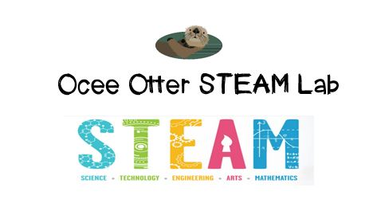
Dear Second Grade Parent,
We had so much fun during our visit to the STEAM Lab! Did you know that the bright colors of flowers help attract insects and birds? We saw beautiful nature photographs showing that bees like blue and purple flowers, hummingbirds prefer red and pink, and butterflies choose yellow and orange. Our challenge was to collaborate with a team to design and build a flower garden that included all six colors of the rainbow. The requirements were that each flower had to be three-dimensional and include all four plant parts. We learned that it’s important to make a plan before starting your work! We also learned that different flowers have many similarities but also many differences.
This lesson incorporated many standards.
Science L1 Students will investigate the life cycles of different living organisms.
c. Investigate the life cycle of a plant by growing a plant from a seed and by recording changes over a period of time.
Art CU1a Recognizes self as an artist.
Art PR1c Combines materials in new and inventive ways to make a finished work of art.
Art C1a Creates artworks inspired by ideas from literature, science, music and/or math.
Talented and Gifted Creative Problem Solving 4. The student demonstrates skills in fluency and flexibility to solve problems or create new products.
Please help me find out why it’s so important for animals to be “pollinators.” Maybe we could take a walk to identify the flowers and insects and birds in our own neighborhood.
Please help me research what causes a rainbow. We could even make a rainbow with this simple experiment! http://www.sciencekids.co.nz/experiments/makearainbow.html
With scientific creativity,
Your young problem-solver

PS Check out the STEAM Lab website for pictures of us working and for ideas on where to find more fun projects like this one. http://oceesteamlab.weebly.com/

