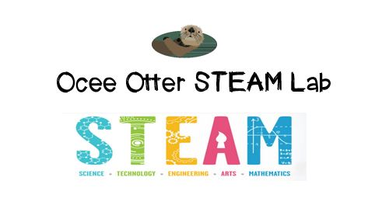
Dear Second Grade Parent,
We had so much fun during our visit to the STEAM Lab using Lego bricks and the Lego Education LearnToLearn Curriculum. First we defined “axle.” Then we created a wheelchair for a mini-figure. We tested and adapted our design until we were satisfied the mini-figure could be moved efficiently, safely, and in style. We were trying to answer the question: How does the design of a vehicle affect its ability to be pushed easily? We also discussed how design thinking can be used to help people accomplish tasks.
This lesson incorporated many standards.
Science P3 Students will demonstrate changes in speed and direction using pushes and pulls.
Science CS 3b Students will assemble, describe, take apart, and reassemble constructions using interlocking blocks, erector sets, and other things.
Talented and Gifted Creative Problem Solving 2 The student designs, applies, evaluates, and adapts a variety of innovative strategies when problem solving.
Talented and Gifted Creative Problem Solving 4 The student demonstrates skills in fluency and flexibility to solve problems or create new products.

Please help me brainstorm other inventions that help people with disabilities.
A trip to the Legoland Discovery Center in Phipps Plaza would be a great family field trip to extend this lesson. The Museum of Design Atlanta offers littleBits classes, in which children use design thinking to build something, such as an animal, and then make it move by adding circuits.
With scientific creativity,
Your young problem-solver
PS Check out the STEAM Lab website for pictures of us working. And the Resources page has many ideas on where to find more fun projects like this one. http://oceesteamlab.weebly.com/

