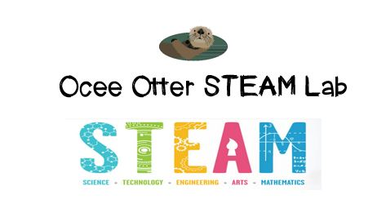
Dear Second Grade Parent,
We had so much fun during our visit to the STEAM Lab! First, we learned the difference between kinetic energy and potential energy. Then, our engineering design challenge was to use limited materials to design and build a catapult that would launch a candy pumpkin the farthest distance. Lastly, we looked at some paintings by Jackson Pollock, who used the energy of flowing paint to create his work.
This lesson incorporated many standards.
Math MD.1 Measure the length of an object by selecting and using appropriate tools such as rulers, yardsticks, meter sticks, and measuring tapes.
Science P2. Students will identify sources of energy and how the energy is used.
Science P3. Students will demonstrate changes in speed and direction using pushes and pulls.
Talented and Gifted Advanced Research 6. The student develops and uses systematic procedures for recording and organizing information.
Talented and Gifted Creative Problem Solving 3. The student incorporates brainstorming and other idea-generating techniques to solve problems or create new products.
Talented and Gifted Creative Problem Solving 4. The student demonstrates skills in fluency and flexibility to solve problems or create new products.
Art CU2. Views and discusses selected artworks, cultures and artists.

Could we please try catapult painting in our backyard? These directions look so fun!
http://fun-a-day.com/catapult-painting-art-activity-for-kids/

With scientific creativity,
Your young problem-solver

Check out the Resources page of the STEAM Lab website for ideas on where to find more fun projects like this one. http://oceesteamlab.weebly.com/

