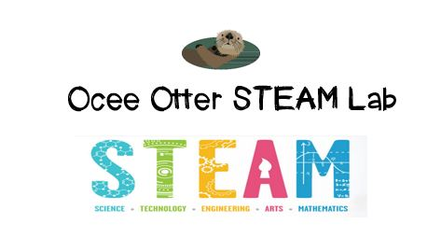
Dear First Grade Parent,
We had so much fun during our visit to the STEAM Lab! First, we looked at photographs of various types of birds’ nests. Then, our engineering design challenge was to collaborate with a team to design and build a safe nest for a candy “peep” bird. We had limited materials to use and a goal of a certain height and strength. We discussed what worked and what didn’t, as well as why birds create nests. We then brainstormed how other animal species protect their young.
This lesson incorporated many standards.
S1L1. Students will investigate the characteristics and basic needs of plants and animals.
Art MC.1. Engages in the creative process to generate and visualize ideas.
Art PR.3. Understands and applies media, techniques, and processes of three-dimensional works of art (ceramics, sculpture, crafts, and mixed-media) using tools and materials in a safe and appropriate manner to develop skills.
Talented And Gifted Creative Problem-Solving 4. The student demonstrates skills in fluency and flexibility to solve problems or create new products.
Talented And Gifted Creative Problem-Solving 6. The student, independently or through collaboration with classmates, clarifies, illustrates, or elaborates on an idea for product improvement.
Talented And Gifted Creative Problem-Solving 9. The student recognizes and assumes risks as a necessary part of problem solving.
Talented And Gifted Creative Problem-Solving 10. The student monitors and reflects on the creative process of problem solving for future applications.

There are lots of things we can do at home to extend this lesson!
- Let’s take a Family Field Trip to one of the many Nature Centers in the Atlanta area.
- We can create a beautiful paper nest sculpture with these directions. http://www.artbarblog.com/recycled/diy-bird-nests/
- We can research how humans have re-created protective homes for animals by visiting Zoo Atlanta.

Check out the “Resources” page of the STEAM Lab website for more ideas on where to find more fun projects like this one, and the “Lessons” page to see pictures of us working. http://oceesteamlab.weebly.com/
With scientific creativity,
Your young problem-solver

