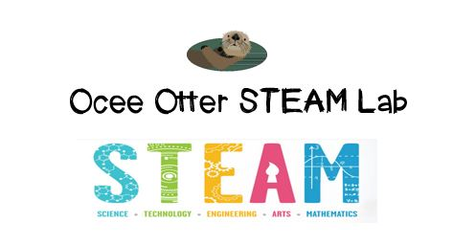
Dear First Grade Parent,
We had so much fun during our visit to the STEAM Lab! We used a kit called Q-BA-Maze 2.0 which has cubes in different colors that interlock to form a marble run. Our challenges were: 1) build a maze in which the marble stays the longest; 2) build a maze that makes the marble move the fastest; 3) build a maze in the shape of an animal; 4) build a maze where pieces of the same color do not touch each other. These challenges helped us understand the difference between kinetic and potential energy and a push versus a pull. Did you know that the definition of energy is “the ability to do work”?
This lesson incorporated many standards.
S1CS3. Students will use tools and instruments for observing, measuring, and manipulating objects in scientific activities.
S1CS6. Students will be familiar with the character of scientific knowledge and how it is achieved.
Talented and Gifted Creative Problem Solving 4. The student demonstrates skills in fluency and flexibility to solve problems or create new products.
Talented and Gifted Creative Problem Solving 6. The student, independently or through collaboration with classmates, clarifies, illustrates, or elaborates on an idea for product improvement.
Talented and Gifted Creative Problem Solving 9. The student recognizes and assumes risks as a necessary part of problem solving.
Talented and Gifted Higher Order Thinking 5. The student predicts probable consequences of decisions.

Did you know that we can even paint a picture using a marble maze? Let’s try this!
http://www.housingaforest.com/marble-maze-painting/
With scientific creativity, Your young problem-solver
Check out the Resources page of the STEAM Lab website for ideas on where to find more fun projects like this one. http://oceesteamlab.weebly.com/
And the Lessons page has pictures of us working! http://oceesteamlab.weebly.com/first-grade.html

