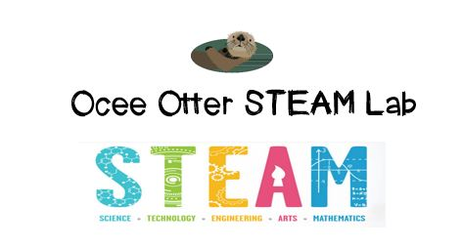
Dear First Grade Parent,
We had so much fun today during our visit to the STEAM Lab using Lego bricks and the Lego Education LearnToLearn Curriculum. First we played a drawing game where we learned that if you aren’t clear and specific when speaking, others might misunderstand what you mean. Then we sat back to back with a partner. We each built a secret design and explained it to our partner in precise language, and our partner tried to build a replica of our design by following our description. We then compared the two to see if they were identical, or where our directions could have been more easily understood. We were trying to answer the question: Why is it important to clearly communicate with others? Check out pictures of us working at http://oceesteamlab.weebly.com/.
This lesson incorporated many standards.
Science CS5 Students will communicate scientific ideas and activities clearly.
a Describe and compare things in terms of number, shape, texture, size, weight, color, and motion.
Math G2 Compose two-dimensional shapes or three-dimensional shapes to create a composite shape, and compose new shapes from the composite shape.
Talented and Gifted Advanced Communication Skills 6 The student anticipates and addresses potential misunderstandings, biases, and expectations in communication with others.
Talented and Gifted Higher Ordering Thinking Skills 6 The student extrapolates verbal-linguistic and visual-spatial patterns to determine relationship.

Please help me brainstorm inventions that help people communicate with each other more easily. We could even design an experiment to test which form of communication is the easiest and most reliable.

With scientific creativity,
Your young problem-solver
PS Check out the Resources page of the STEAM Lab website for ideas on where to find more fun projects like this one. http://oceesteamlab.weebly.com/

