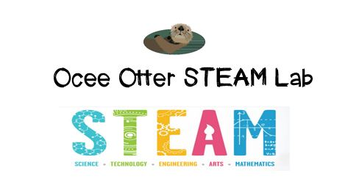
Dear First Grade Parent,
We had so much fun during our visit to the STEAM Lab! First, we made a cloud in a jar! Did you know clouds form around pieces of dust in the air when air gets cold too quickly because the air can’t hold onto the water that’s inside it? Then, our engineering design challenge was to collaborate with a team to design and build a miniature umbrella. We had limited materials to use and a goal of a certain height and strength. We discussed what worked and what didn’t, as well as why people create tools.
This lesson incorporated many standards.
S1E1. Students will observe, measure, and communicate weather data to see patterns in weather and climate.
S1E2. Students will observe and record changes in water as it relates to weather.
Art MC.1. Engages in the creative process to generate and visualize ideas.
Art PR.3. Understands and applies media, techniques, and processes of three-dimensional works of art (ceramics, sculpture, crafts, and mixed-media) using tools and materials in a safe and appropriate manner to develop skills.
TAG Creative Problem-Solving 4. The student demonstrates skills in fluency and flexibility to solve problems or create new products.
TAG Creative Problem-Solving 6. The student, independently or through collaboration with classmates, clarifies, illustrates, or elaborates on an idea for product improvement.
TAG Creative Problem-Solving 9. The student recognizes and assumes risks as a necessary part of problem solving.
TAG Creative Problem-Solving 10. The student monitors and reflects on the creative process of problem solving for future applications.
There are lots of things we can do at home to extend this lesson!
- Let’s take a Virtual Field Trip to a weather station http://www.pbslearningmedia.org/resource/e949742f-b34e-4d73-8f12-4147130355b1/weather-station-field-trip/
- Let’s try some simple Weather Experiments http://www.weatherwizkids.com/weather-experiments.htm
- Let’s write a paragraph and draw a picture to answer each of these questions: What would happen if it never rained again? What would happen if it never stopped raining?
- Let’s design a movement or a dance for different kinds of weather: stormy, sunny, snowy, etc.
- Let’s create a soundtrack for weather: What type of music would match different kinds of weather?
- Let’s read the book Pink Snow and Other Weird Weather by J. Dussling.

Check out pictures of us working on the “Lessons” page of the STEAM Lab website. And the “Resources” page has many ideas on where to find more fun projects like this one. http://oceesteamlab.weebly.com/
With scientific creativity,
Your young problem-solver

